*A Friend For Princess Ada* First Grade Lesson Plan

|  |
| --- |
| State or Common Core Standard and/or Objective: Understand the difference between fact and opinion. |

|  |
| --- |
| **What Taught** - **Instructional Outcomes**  Lesson Objective: Students will understand the difference between a fact and opinion by listening to the book “A Friend for Princess Ada” and identifying the difference between the two with 100% accuracy.  Kid-Friendly Objective: I can tell the difference between a fact and an opinion. |

|  |
| --- |
| Expectations for Student Behavior: Students will sit still and listen at the carpet and raise their hand if they have a question or comment. |

|  |
| --- |
| Launch / Anticipatory Set / Schema Connections: Ask students to think of their favorite animal and share with a partner. Why is it their favorite animal? Have some students share. Notice that not every student has the same favorite animal. That is their opinion. What would be a fact about an animal? Define fact and give an example or two and then ask for more facts. |

|  |  |
| --- | --- |
| **How Taught** - **Instructional Strategies** Aligned with Learning Objective:  -Introduce the book *A Friend for Princess Ada* by reading the title and showing them the picture on the front. Have them make predictions for what will happen.  - Before reading, tell them to look for the facts about animals and princess Ada’s opinion about them.  - Read them the book  - Discuss and write down some of the facts/opinions on a chart while reading.  - At the end of the story, discuss whether there were more facts or opinions they found. (a good pet is playful, a seal barks, lions have jagged teeth, etc.)  - Tell students you will give an example and they will need to decide if it is a fact or opinion. They can raise their right hand if it is an opinion or their left hand if it is a fact, print signs to accommodate. | **How Evaluated** - **Assessments** Aligned with Objective:  Informal- How they participated and were correct in identifying whether a statement was a fact or opinion in the activity.  To close, ask students to think about their favorite animal you said. In your opinion, would they make a good pet? Turn and talk to same partner about what you would say. |

|  |
| --- |
| Materials and Digital Technology Needed to Support Teaching Strategies:   * Book *A Friend for Princess Ada* by Emilee Moore. * Chart paper * Fact/opinion signs with right and left hands |

Fact

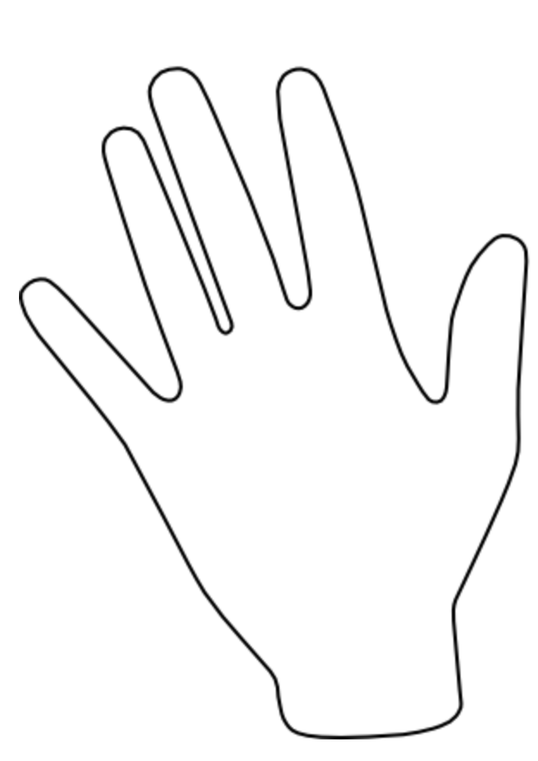

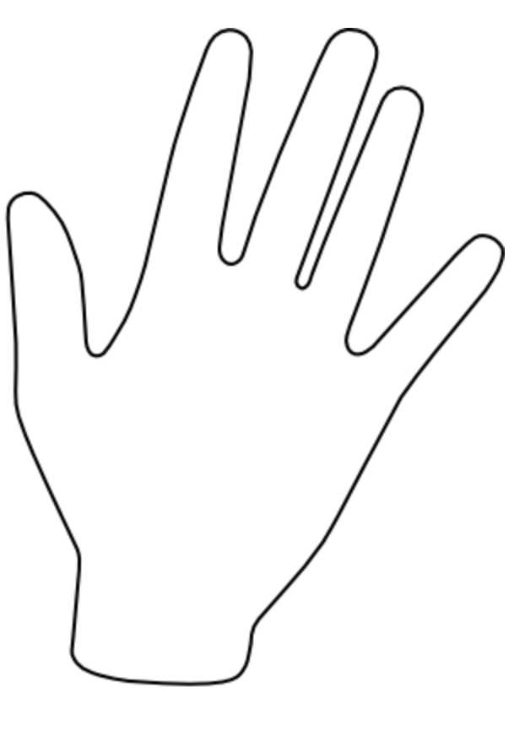Opinion